**NAME-AVIRAL**

**UID-19BCS3755**

**SUBJECT-BEEE LAB**

**AIM:**

Design a system that automatically rings a bell for 2 ms whenever someone enters a temple, assuming only one person can enter at a time.

**CIRCUIT DIAGRAM:**

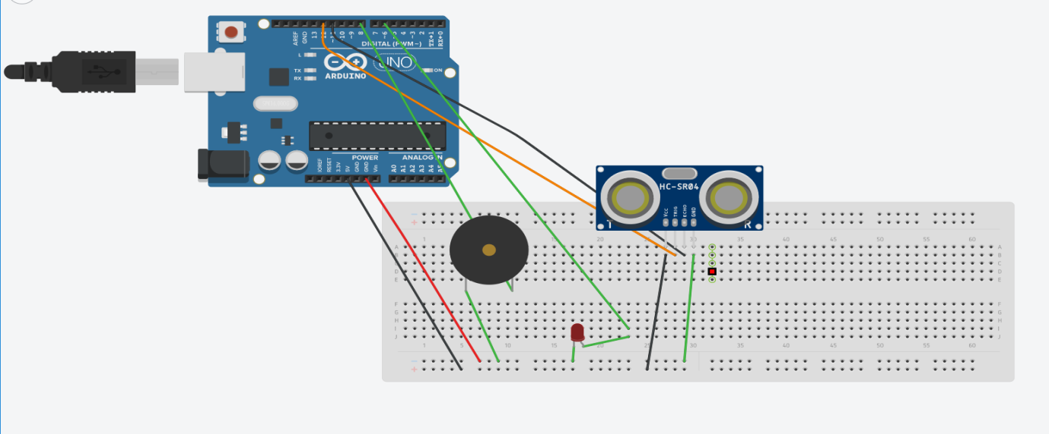

**THEORY:** Arduino is an open-source electronics platform based on easy-to-use hardware and software. Arduino boards are able to read inputs - light on a sensor, a finger on a button

In this project ultrasonic distance sensor is used to detect whether the person is entering the temple or not if it detects any object the beeper/buzzer will start beeping ,in this case for circuit, beeper is used in place of temple bell. Breadboard is used to fix the components.

**LEARNING AND OBSERVATIONS:**

1. Whenever someone enters a temple, bell ring.
2. We observed that when an object come closer to the sensor the LED start glowing and beeper start beeping.
3. We learned how to use ultrasonic distance sensor.

**PROBLEM AND TROUBLESHOOTING:**

1) Setting up a connection.

2) Errors in code,it was corrected after a few trys.

3) Port was not selected.

4) Internet network poor.

**PRECAUTIONS:**

1. Don’t plug in a LED without a resistor.
2. Circuit should be properly set into breadboard.
3. All connections should be made properly.
4. Arduino and other components should be handled with care.

**LEARNING OUTCOMES:**

1. Came to know about Arduino.
2. Came to know about how to design a circuit
3. Came to know about loops.
4. Came to know about ultasonic distance sensor